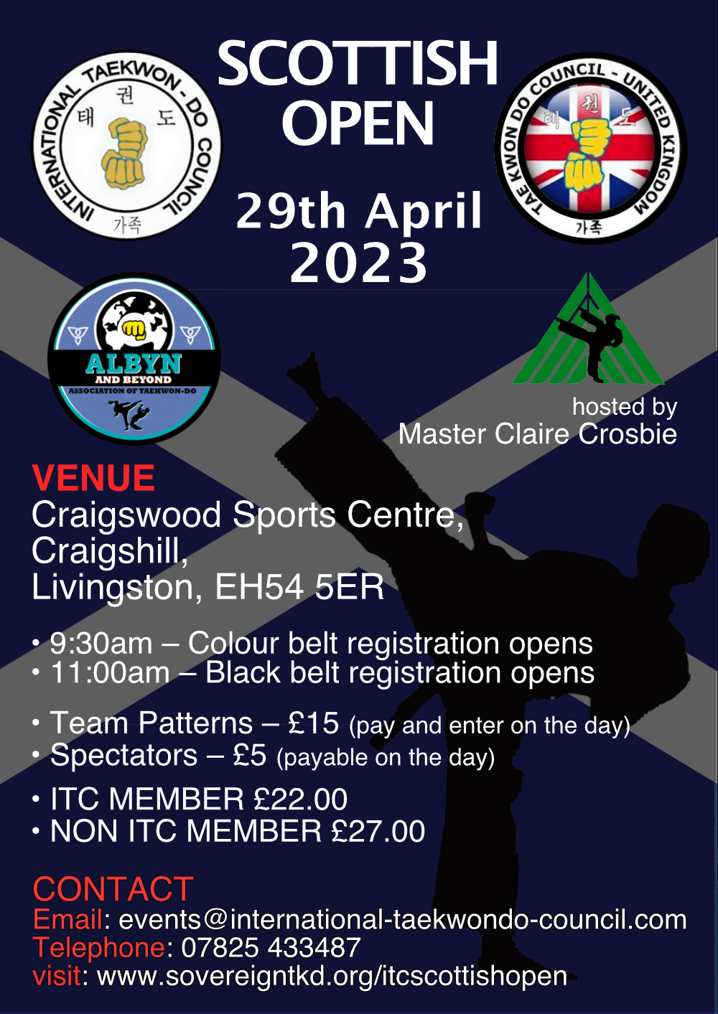

Information Pack
Page Description

1 | Poster
2 | Index
3 | Dear Instructor,
3 | Entry Fee
4 | Instructors Information
4 | Officials
4 | Welfare Officers
4 | First Aid
4 | Photography
5 | Competitors
5 | Closing Dates
6 | Pattern Divisions
7 | Team Patterns
8 | Sparring Divisions
9 | Speed Divisions

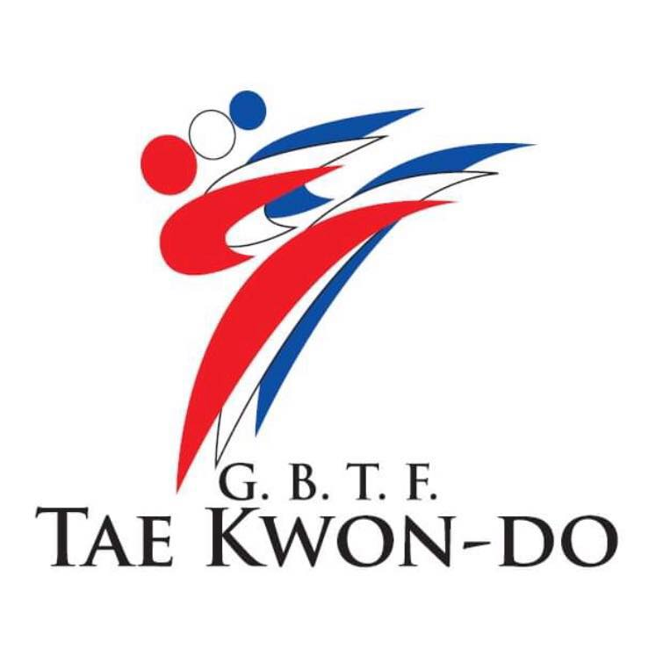
ITC SCOTTISH OPENS 2023
CRAIGSWOOD SPORTS CENTRE
CRAIGSHILL
LIVINGSTON
EH54 5ER

Saturday 29th April 2023

Dear Instructor.

You and your students are invited to attend the above event.

JUNIORS
Coloured Belts Up to & including 17 years old. Black Belts Up to & including 17 years old.

ADULTS
Coloured Belts 18 years & over
Black Belts (Female) 18 years old to 34 years old Black Belts (Male) 18 years old to 34 years old

EXECUTIVE MALE (Optional – for Black Belts Only)
35 years old & over (sparring)

EXECUTIVE FEMALE (Optional – for Black Belts Only)
35 years old & over (sparring)

ALL Coloured belt Competitors to arrive by 9.30 A.M. ALL Black Belts Competitors to arrive by 11.00 A.M
ENTRY FEES:

Competitor: eCard £22.00
Non eCard: £27.00
ITC Squad Members will get a refund within 48 hours of event.
Includes both Individual Patterns and Sparring
Spectators: £5.00 (5 years old & under FREE)
To be paid on door
Team Events: £15.00 per 3–5-person team.
To be paid & entered on the day.

Please enter online - https://www.sovereigntkd.org/itcscottishentry
INSTRUCTORS INFORMATION:
All instructors who have competitors taking part in this competition should attend themselves or delegate a senior person who is a competitor or official to assist their students in the event of any problems that may arise on the day, this is usually the children.
If downloading and doing manual entries via instructor, please ensure completed correctly. This causes a lot of the problems.

Please remind all spectators that they ARE NOT ALLOWED onto the competition area.

Only Officials and competitors (who must be wearing their dobok) are allowed on the competition area.

Failure to adhere to these rules could result in them being asked to leave the tournament venue.

OFFICIALS.
Officials where possible must be Red Belts who have attended at least Part 1 of ITC Umpire Course.
Officials should wear smart grey/black/navy trousers and sports shoes along with shirt and tie which shows their organisations logo.
Blazer/Jackets must be worn when judging patterns.
All officials must register at official desk by the door when entering on the day.

WELL-BEING OFFICERS:
There will be Well-being officers at the event who will be identified by hi viz t-shirts.

FIRST AID:
A third-party first aid team will be in attendance.

PHOTOGRAPHY:
This is a public event, photos maybe taken by the official photographers and members of the public. These images maybe used for marketing or social media purposes.
If someone cannot appear in photos, please let us know and we’ll do our best to accommodate.

COMPETITORS:
All competitors must wear a dobok that is approved by their instructor/club. All sparring competitors must have the following.
- Point stop gloves, with enclosed fingers, no weighted gloves allowed
- Headguard
- Shins
- Feet/boots
- Mouth Guard
- forearm protectors are optional
- Groin guards for male competitors.

ENTRY CLOSING DATES: 24 Hours before

PATTERN DIVISIONS
All competitors must perform a pattern of their grade.
Genders will be mixed.

Juniors (11 Years and Under)
White (10th Kup to 9th Kup)
Yellow (8th Kup to 7th Kup)
Green (6th Kup to 5th Kup)
Blue (4th Kup to 3rd Kup)
Red (2nd Kup to 1st Kup)
Black (All grades together)
Boys & Girls in Combined divisions
Cadets (12-17 Years) – Maybe split further depending on entries.
White (10th Kup to 9th Kup)
Yellow (8th Kup to 7th Kup)
Green (6th Kup to 5th Kup)
Blue (4th Kup to 3rd Kup)
Red (2nd Kup to 1st Kup)
Black (All grades together)
Male & female in Combined divisions.

Adults
White (10th Kup to 9th Kup)
Yellow (8th Kup to 7th Kup)
Green (6th Kup to 5th Kup)
Blue (4th Kup to 3rd Kup)
Red (2nd Kup to 1st Kup)
Black (1) (1ST Dan Only)
Black (2+3) (2nd & 3rd Dan)
Black (4+) (4th Dan and above)
Male & female in Combined divisions.
Divisions will be combined if less than 4 competitors.

Patterns
All Coloured Belt competitors must perform a pattern up to/including their current grade All Black Belt competitors must perform a pattern of their grade or previous Grade.
Medals awarded 1 x Gold 1 x Silver 1 x Bronze

TEAM PATTERN COMPETITION
Divisions

Mixed Male/Female/Junior/Seniors 3-5 competitors in a team
Split as follows

Mixed Colourbelts

All Dan Grades

RULES OF THE COMPETITION

Each team to perform a pattern unison.

Pattern to be scored in the same way as in individual pattern events. The pattern to be relevant to the most junior grade in the team.
(e.g., A team with a 9th Kup in can only perform Chon Ji and a team with a 3rd Kup in can perform any pattern up to and including Toi Gye)

Scoring to be based on the following: -

- The correctness of the pattern moves

- Power, balance, focus, fluidity etc. As per individual pattern competition.

- Synchronisation of all members when performing the pattern.

Cost £5 per person.

ENTRY IS ON THE DAY AT THE MAIN DESK

Only Gold Medals
SPARRING DIVISIONS

Juniors

Years and Under
Point stop – Up to and including Blue Tag Continuous – Blue Belts and above
Divisions will be done on the day; students will be rowed up and split into fair and safe groups.
Boys and Girl Separate
All the above divisions 1 x 1.5-minute rounds.
Medals awarded 1 x Gold 1 x Silver 1 x Bronze

Seniors
- Years plus
Point stop – Up to and including Blue Tag Continuous – Blue Belts and above Divisions will be calculated by weight Male and Female separate.
All the above divisions 1 x 1.5-minute rounds.
Medals awarded 1 x Gold 1 x Silver 1 x Bronze

Executives – Can be entered in Addition to Seniors
35 Years Plus Blackbelts Only Point stop
Divisions will be calculated by weight Male and Female separate.
All the above divisions 1 x 1.5-minute rounds.
Medals awarded 1 x Gold 1 x Silver 1 x bronze

SPEED DIVISIONS

Turning Kick of front leg onto a paddle
Held at Shoulder Height
Foot must touch floor between kicks
Number of kicks in 30 Seconds
Juniors and Cadets only
Gold, Silver, and Bronze will be awarded.

Juniors (12 Years and Under)
White (10th Kup to 9th Kup)
Yellow (8th Kup to 7th Kup)
Green (6th Kup to 5th Kup)
Blue (4th Kup to 3rd Kup)
Red (2nd Kup to 1st Kup)
Black (All grades together)
Boys & Girls in Combined divisions

Cadets (13 -17 Years)
White (10th Kup to 9th Kup)
Yellow (8th Kup to 7th Kup)
Green (6th Kup to 5th Kup)
Blue (4th Kup to 3rd Kup)
Red (2nd Kup to 1st Kup)
Black (All grades together)
Male & female in Combined divisions

